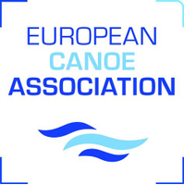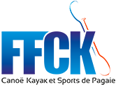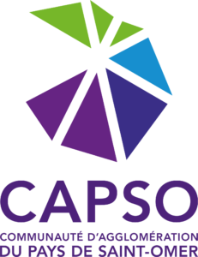

Dears canoe polo friends,

As you know, the COVID 19 crisis has an important impact for the organizers of sporting events.

The Canoe Kayak Club of Saint-Omer do everything in its power to be able to host the European Club Championships, scheduled for October 3 and 4.

Unfortunately, we are currently unable to guarantee the running of the event.

A meeting of the organizing committee will be held on September 4 to determine if we will be able to maintain the organization of the European Club Championships, with good sanitary conditions for everyone.

However, in order to be more responsive and to be able to transmit information to qualified teams as quickly as possible, we are now setting up a pre-registration system.

The final registration and all the necessary information will be available on September 4, when we are sure we can organize the Championships. It should be noted that no registration will be accepted if the pre-registration has not been made within the time allocated.

ECA CLUBS CHAMPIONSHIPS

Final registration

_______________________________________________________________________________________________________________________________
Name of the team category Men / Women

Address Country

Team Leader / Contact

Telephone E-mail

__________________________ ____________ _________
City, date Signature of national federation Stamp of National Federation

This form must be returned to the
Kayak-Polo European Club
Championship Organising Committee
before September 1st 2020

CKCSO – ck.stomer@orange.fr

