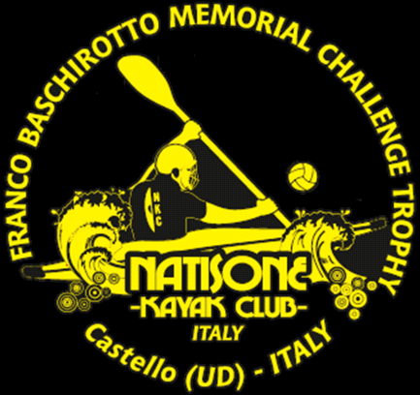 | TEAM REGISTRATION FORM  30° FRANCO BASCHIROTTO MEMORIAL 2019  Castello di Porpetto (UD) Italy  13 & 14 July 2019

TEAM INFORMATION
TEAM NAME:
PERSON RESPONSABLE:
CONTACT PHONE NUMBER:
E-MAIL:
PLAYING DIVISION: |  |  | □ Division I (ELITE) - MAX 12 TEAMS |  | □ Division II (RECREATIONAL) - MAX 16 TEAMS
 |  |  | □ Division III Ladies - MAX 6 TEAMS |  | □ Division IV Junior U18 – MAX 6 TEAMS
ATHLETES INFORMATION (fill in date of birth only for Junior U18 Division athletes)
No. | VEST # | FIRST NAME |  | LAST NAME |  | DATE OF BIRTH | SHIRT SIZE
1
2
3
4
5
6
7
8
9
10
REFEREES
 | FIRST NAME |  |  | LAST NAME |  | NATIONAL REFEREE LEVEL
1ST
2ND
PLUS THREE PEOPLE FROM YOUR CLUB FOR TABLE DUTIES – NO NEED NAME SPECIFICATION
(CHRONOMETER TIME-KEEPER/SHOT-CLOCK TIME-KEEPER/SCORECARD OFFICIAL)
N.B. If unable to provide the two referees a compensation fee of € 100 has to paid in advance together with the registration to cover costs of providing alternative game officials.
REGISTRATION FEE: € 100 for each team.
Payment to Natisone Kayak Club: BANCATER CREDITO COOPERATIVO FVG - IBAN IT19Z0863163930000000855696.
Please specify on payment receipt ‘Registration for 30° Franco Baschirotto Memorial 2019’ and playing division.
If using campsite add € 20 as a ‘one-time’ fee camping fee (for each team) together with payment Proof of payment fees must be sent within 30th June 2019 to guarantee participation in the Tournament.
Free commemorative ‘30° Anniversary Edition’ polo shirts for all teams that register only before 30 May 2019.
Return this filled out form to: natisonekayakclub@gmail.com within Sunday 7 July 2019. Thank you.
POLO SHIRT SIZES: 3XL, 2XL, XL, L, M, S

